

**Submitted By: group-14**

**Name: Shakil Ahmed**

**ID: 222 1453 042**

**Name: Nael**

**ID: 2212254642**

**Project: Bangladesh National Management Portal**

**Course Code: CSE311**

**Section : 12**

**Date of Submission: 02-12-2024**

**North South University**

**Department**

**of**

**Electrical and Computer Engineering**

**Submitted By: group-14**

**Name: Shakil Ahmed**

**ID: 222 1453 042**

**Name: Nael**

**Id: 2212254642**

**Bangladesh National Portal Management System**

The **Bangladesh National Portal Management System (BNPMS)** is designed to consolidate public services and resources, providing citizens with an efficient way to request services and interact with government entities. The system will also empower government officials to manage requests and monitor service delivery, thereby improving transparency, efficiency, and accountability.

**1. Project Overview**

The BNPMS aims to serve as a centralized digital platform where:

* Citizens can request government services, track request statuses, and provide feedback.
* Government departments can manage service requests, monitor feedback, and oversee departmental operations.
* Government officials can access department-specific data, track performance metrics, and oversee service delivery.

**2. Database Scope**

The database is structured to support complex interactions between users, service requests, and government departments. It includes multiple types of entities and relationships to reflect real-world processes accurately.

**Entities and Attributes**

1. **User Types**:
   * **User**: A generalized entity containing basic attributes such as *User ID*, *Full Name*, *Username*, *Password*, *Email*, and *Notification Preferences*.
   * **Specialized User Types**:
     + **Citizen**: Specific attributes include *Citizen ID*, *Name*, *Date of Birth*, *Nationality*, *Marital Status*, *Occupation*, *Address* (present and permanent), and *Contact Information*. Derived attributes like *Age* are calculated from the date of birth.
     + **Expat**: Contains attributes relevant to foreign workers, such as *Visa Type*, *Work Permit Status*, *Expected Departure Date*, *Entry Date*, *Bank Account*, and *Origin*.
2. **NID_Card**:
   * Related to *Citizen*, it represents details from the national ID card, including *NID*, *Father’s Name*, *Mother’s Name*, *Date of Issue*, *Expiry Date*, *Blood Type*, *Place of Birth*, and *Signature*.
3. **Government Department**:
   * Government Official: Includes Official ID, Employment Type, Date of Appointment, Rank, Work Location, Supervisor, and Training Records. Officials manage or oversee services within departments.
   * Represents government departments with attributes such as *Department ID*, *Department Name*, *Founding Date*, *Location*, *Budget*, *Number of Employees*, *Contact Information*, and *Key Policies*.
   * Relationships like Under and Department_Head reflect hierarchical structures and management within government entities.
4. **Government Official:**
   * Includes *Official ID*, *Employment Type*, *Date of Appointment*, *Rank*, *Work Location*, *Supervisor*, and *Training Records*. Officials manage or oversee services within departments. There will be another specified field which will be called role and it will be Government official itself. A slected few persons will be elected as department head for certain period of time and this is implimented via role which we call Department_Head
5. **Services**:
   * Represents services provided by government departments. Attributes include *Service ID*, *Service Type*, *Service Description*, *Application Process*, *Priority Level*, *Documents Required*, and *Service History*.
6. **Service Request**:
   * Represents individual requests made by citizens for government services. Attributes include *Request ID*, *Request Status*, *Request Description*, *Supporting Evidence*, and the department responsible for handling the request.
   * Specialization into *Pending* and *Completed* allows for managing requests based on their current status:
     + **Pending Requests**: Includes attributes like *Submission Date*, *Last Updated Date*, *Department in Charge*, and *Follow-up Requirement*.
     + **Completed Requests**: Contains *Completion Date*, *Approval Status*, *Resolution Summary*, and *Final Processing*.
7. **Service Feedback**:
   * Allows citizens to provide feedback on services received. Attributes include *Feedback ID*, *Feedback Date*, *Comments*, *Rating*, and *Final Document Issued*.
8. **Notifications**:
   * Represents messages sent to users about service updates and important alerts, containing attributes like *Notification ID*, *Message*, *Notification Type*, and *Date Sent*.

**Relationships and Constraints**

1. **Hierarchies**:
   * The ISA relationship between *User* and specialized types (*Citizen*, *Government Official*, *Expat*) allows for role-based access and tailored functionality for different user types.
2. **Ternary Relationships**:
   * For example, the relationship among *Citizen, Expat* and *Service* enables detailed tracking of which service request is necessary for the user.
3. **Access Control**:
   * Roles and relationships (e.g., *Citizen*’s Can request for *Services*) define access permissions, ensuring that citizens can access their requests and government officials can oversee department-specific data.
4. **Cascading Actions**:
   * The database will enforce cascading updates and deletions. For example, if a department is removed, all associated service requests will be automatically deleted to maintain data integrity.

**3. Implementation Scope**

**Database Design**

1. **Keys and Constraints**:
   * Primary keys (e.g., *Citizen ID*, *Department ID*) and foreign keys will enforce data integrity.
   * Constraints will ensure valid data entry, such as mandatory fields for *Request Status* and *Service Type*.
2. **Composite and Multivalued Attributes**:
   * Attributes like *Name* composite.
   * Some attributes, like *Contact Information* for Citizen for example email, phone are multivalued to allow multiple entries.
3. **Derived Attributes**:
   * Certain attributes, like *Age*, will be derived from other data points, such as date of birth.

**Stored Procedures and Functions**

1. **Functions**:
   * Functions will calculate metrics like the total number of requests by a citizen or the average processing time for requests in each department.
2. **Procedures**:
   * Stored procedures will automate key tasks:
     + Assigning requests to government officials.
     + Updating request statuses based on progress.
     + Generating periodic reports for tracking department performance and citizen satisfaction.

**Front-End Functionality**

1. **User Interface and Interactions**:
   * The interface will support CRUD (Create, Read, Update, Delete) operations on major entities:
     + **Service Requests**: Citizens can submit new requests, view request statuses, update details, and delete outdated requests.
     + **Service Feedback**: Citizens can leave feedback on completed services, providing insights for improvement.
     + **Department Management**: Officials can manage department details, ensuring records are up-to-date.
2. **Notifications and Alerts**:
   * A notification system will keep citizens informed about the status of their requests and send important updates or alerts.
3. **Role-Based Access Control**:
   * Role-based views and permissions will allow citizens to access personal data, while officials have broader department-specific access, and administrators can oversee all data.

**4. Expected Outcomes**

This scope defines a robust and scalable BNPMS that will support:

* **Enhanced Citizen Engagement**: Through service request tracking, feedback collection, and notifications, citizens will feel more connected and empowered.
* **Improved Efficiency for Government Officials**: With streamlined data and automated tasks, officials can manage service requests more effectively.
* **Increased Transparency**: By enabling citizens to view request statuses and provide feedback, the system will promote government accountability.

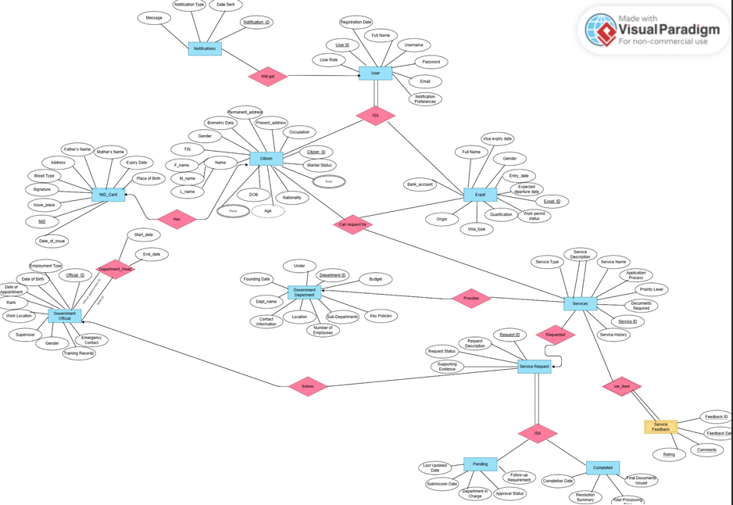

Relational schema-   
  
Citizen (**Citizen_ID**, F_name, M_name, L_name, Gender, DOB, Nationality, Marital_Status, Occupation, Present_address, Permanent_address, Biometric_Data, TIN)   
  
Expat (**Expat_ID**, Full_Name, Gender, Origin, Visa_type, Visa_expiry_date, Qualification, Entry_date, Expected_departure_date, Work_permit_status, Bank_account)   
  
NID_Card (**NID**, Citizen_ID, Fathers_Name, Mothers_Name, Address, Blood_Type, Signature, Place_of_Birth, Issue_place, Expiry_date, Date_of_issue)   
  
User (**User_ID**, Full_Name, Username, Password, Email, User_Role, Notification_Preferences, Registration_Date)   
  
Government_Official (**Official_ID**, Full_Name, Date_of_Birth, Employment_Type, Date_of_Appointment, Rank, Work_Location, Supervisor, Gender, Emergency_Contact, Training_Records)   
  
Government_Department (**Department_ID**, Dept_name, Founding_Date, Location, Contact_Information, Budget, Key_Policies, Number_of_Employees, Sub_Department)   
  
Services (**Service_ID**, Department_ID, Request_ID, Service_Name, Service_Type, Service_Description, Application_Process, Priority_Level, Documents_Required, Service_History)   
  
Notifications (**Notification_ID**, User_ID, Message, Notification_Type, Date_Sent)   
  
Service Request (**Request_ID**, Official_ID, Request_Status, Request_Description, Supporting_Evidence)   
  
Pending (**Request_ID**, Last_Updated_Date, Submission_Date, Department_in_Charge, Approval_Status, Follow_up_Requirement)   
  
Completed (**Request_ID**, Completion_Date, Resolution_Summary, Final_Documents_Issued, Total_Processing_Time)   
  
Service Feedback (**Service_ID,Feedback_ID, Rating, Comments, Feedback_Date)**   
  
Department_Head (**Head_ID, Official_appointment_ID, Start_date, End_date)**   
  
Can request for (**Service_ID, Citizen_ID, Expat_ID)**   
  
Citizen_email**(Citizen_ID, citizen_email**)   
  
Citizen_phone **(Citizen_ID, citizen_phone**)

**DDL :**

**CREATE TABLE `users` (**

**`UserID` int(12) NOT NULL AUTO_INCREMENT PRIMARY KEY,**

**`Username` varchar(50) NOT NULL,**

**`Password` varchar(255) NOT NULL,**

**`Email` varchar(100) DEFAULT NULL,**

**`NotificationPreferences` varchar(50) DEFAULT NULL,**

**`type` varchar(50) DEFAULT NULL,**

**`date_registered` DATETIME DEFAULT CURRENT_TIMESTAMP**

**) ENGINE=InnoDB DEFAULT CHARSET=utf8mb4 COLLATE=utf8mb4_general_ci;**

**CREATE TABLE `citizen` (**

**`CitizenID` int(12) NOT NULL AUTO_INCREMENT PRIMARY KEY,**

**`UserID` int(12) NOT NULL,**

**`FullName` varchar(100) DEFAULT NULL,**

**`DateOfBirth` date DEFAULT NULL,**

**`Nationality` varchar(50) DEFAULT NULL,**

**`MaritalStatus` varchar(20) DEFAULT NULL,**

**`Occupation` varchar(50) DEFAULT NULL,**

**`addressPresent` varchar(255) DEFAULT NULL,**

**`addressPermanent` varchar(255) DEFAULT NULL,**

**`ContactInfo` varchar(100) DEFAULT NULL,**

**`Age` int(10) DEFAULT NULL,**

**`TIN` int(20) DEFAULT NULL,**

**FOREIGN KEY (`UserID`) REFERENCES `users` (`UserID`) ON DELETE CASCADE**

**) ENGINE=InnoDB DEFAULT CHARSET=utf8mb4 COLLATE=utf8mb4_general_ci;**

**CREATE TABLE `expat` (**

**`ExpatID` int(11) NOT NULL AUTO_INCREMENT PRIMARY KEY,**

**`UserID` int(12) NOT NULL,**

**`VisaType` varchar(50) DEFAULT NULL,**

**`WorkPermitStatus` varchar(50) DEFAULT NULL,**

**`ExpectedDepartureDate` date DEFAULT NULL,**

**`EntryDate` date DEFAULT NULL,**

**`BankAccount` varchar(50) DEFAULT NULL,**

**`Origin` varchar(50) DEFAULT NULL,**

**`PassportNumber` varchar(50) DEFAULT NULL,**

**FOREIGN KEY (`UserID`) REFERENCES `users` (`UserID`) ON DELETE CASCADE**

**) ENGINE=InnoDB DEFAULT CHARSET=utf8mb4 COLLATE=utf8mb4_general_ci;**

**CREATE TABLE `governmentofficial` (**

**`OfficialID` int(11) NOT NULL AUTO_INCREMENT PRIMARY KEY,**

**`Username` varchar(50) NOT NULL UNIQUE,**

**`FullName` varchar(100) NOT NULL,**

**`Password` varchar(255) NOT NULL,**

**`EmploymentType` varchar(50) DEFAULT NULL,**

**`DateOfAppointment` date DEFAULT NULL,**

**`WorkLocation` varchar(100) DEFAULT NULL,**

**`Supervisor` int(11) DEFAULT NULL**

**) ENGINE=InnoDB DEFAULT CHARSET=utf8mb4 COLLATE=utf8mb4_general_ci;**

**CREATE TABLE `department` (**

**`DepartmentID` int(11) NOT NULL AUTO_INCREMENT PRIMARY KEY,**

**`DepartmentName` varchar(100) NOT NULL,**

**`FoundingDate` date DEFAULT NULL,**

**`Location` varchar(100) DEFAULT NULL,**

**`Budget` decimal(15,2) DEFAULT NULL,**

**`NumberOfEmployees` int(11) DEFAULT NULL,**

**`ContactInfo` varchar(100) DEFAULT NULL,**

**`KeyPolicies` text DEFAULT NULL**

**) ENGINE=InnoDB DEFAULT CHARSET=utf8mb4 COLLATE=utf8mb4_general_ci;**

**CREATE TABLE `services` (**

**`ServiceID` int(11) AUTO_INCREMENT PRIMARY KEY,**

**`ServiceType` varchar(100) NOT NULL,**

**`DepartmentID` int(11) NOT NULL,**

**`ServiceDescription` text DEFAULT NULL,**

**`ApplicationProcess` text DEFAULT NULL,**

**`PriorityLevel` varchar(20) DEFAULT NULL,**

**`DocumentsRequired` text DEFAULT NULL,**

**`ServiceHistory` text DEFAULT NULL,**

**FOREIGN KEY (`DepartmentID`) REFERENCES `department` (`DepartmentID`) ON DELETE CASCADE**

**) ENGINE=InnoDB DEFAULT CHARSET=utf8mb4 COLLATE=utf8mb4_general_ci;**

**CREATE TABLE `servicerequest` (**

**`RequestID` int(11) NOT NULL AUTO_INCREMENT PRIMARY KEY,**

**`CitizenID` int(12) NOT NULL,**

**`ServiceID` int(11) DEFAULT NULL,**

**`RequestStatus` varchar(50) NOT NULL DEFAULT 'Pending',**

**`RequestDescription` text DEFAULT NULL,**

**`SupportingEvidence` text DEFAULT NULL,**

**FOREIGN KEY (`CitizenID`) REFERENCES `citizen` (`CitizenID`) ON DELETE CASCADE,**

**FOREIGN KEY (`ServiceID`) REFERENCES `services` (`ServiceID`) ON DELETE SET NULL**

**) ENGINE=InnoDB DEFAULT CHARSET=utf8mb4 COLLATE=utf8mb4_general_ci;**

**CREATE TABLE `admin` (**

**`Username` varchar(50) NOT NULL PRIMARY KEY,**

**`FullName` varchar(100) NOT NULL,**

**`Password` varchar(255) NOT NULL**

**) ENGINE=InnoDB DEFAULT CHARSET=utf8mb4 COLLATE=utf8mb4_general_ci;**

**INSERT INTO services (ServiceType) VALUES ('Passport');**

**INSERT INTO services (ServiceType) VALUES ('Transport');**

**INSERT INTO services (ServiceType) VALUES ('Citizenship');**

**CREATE TABLE `review` (**

**`ReviewID` INT(11) NOT NULL AUTO_INCREMENT PRIMARY KEY,**

**`RequestID` INT(11) NOT NULL,**

**`CitizenID` int(12) NOT NULL,**

**`ServiceID` INT(11) NOT NULL,**

**`Review` TEXT DEFAULT NULL,**

**`DateSubmitted` DATETIME DEFAULT CURRENT_TIMESTAMP,**

**FOREIGN KEY (`CitizenID`) REFERENCES `citizen`(`CitizenID`) ON DELETE CASCADE,**

**FOREIGN KEY (`RequestID`) REFERENCES `servicerequest`(`RequestID`) ON DELETE CASCADE,**

**FOREIGN KEY (`ServiceID`) REFERENCES `services`(`ServiceID`) ON DELETE CASCADE**

**) ENGINE=InnoDB DEFAULT CHARSET=utf8mb4 COLLATE=utf8mb4_general_ci;**

**Dashboard** 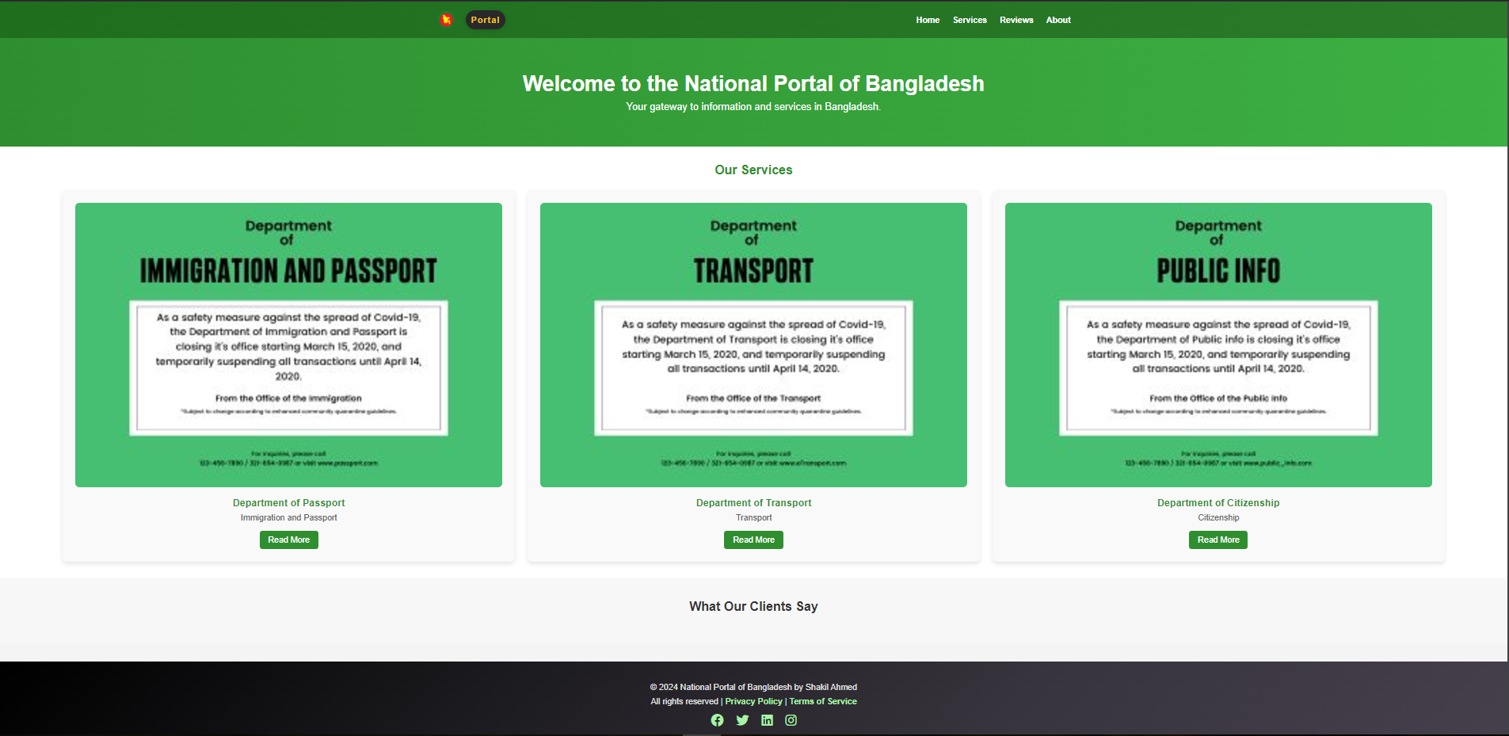

**User**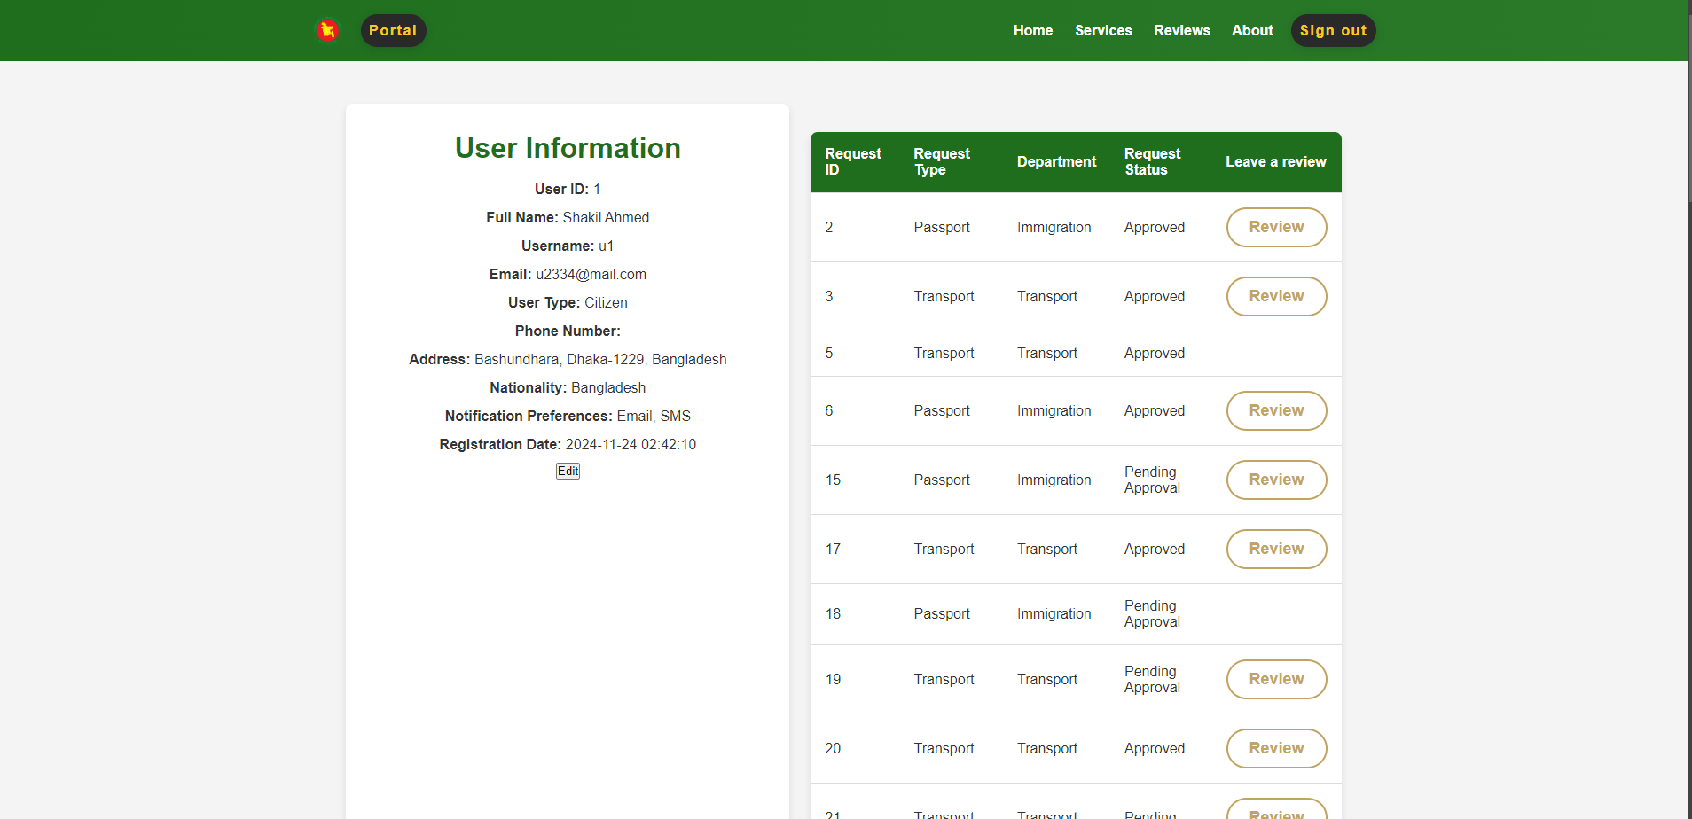

**Official**

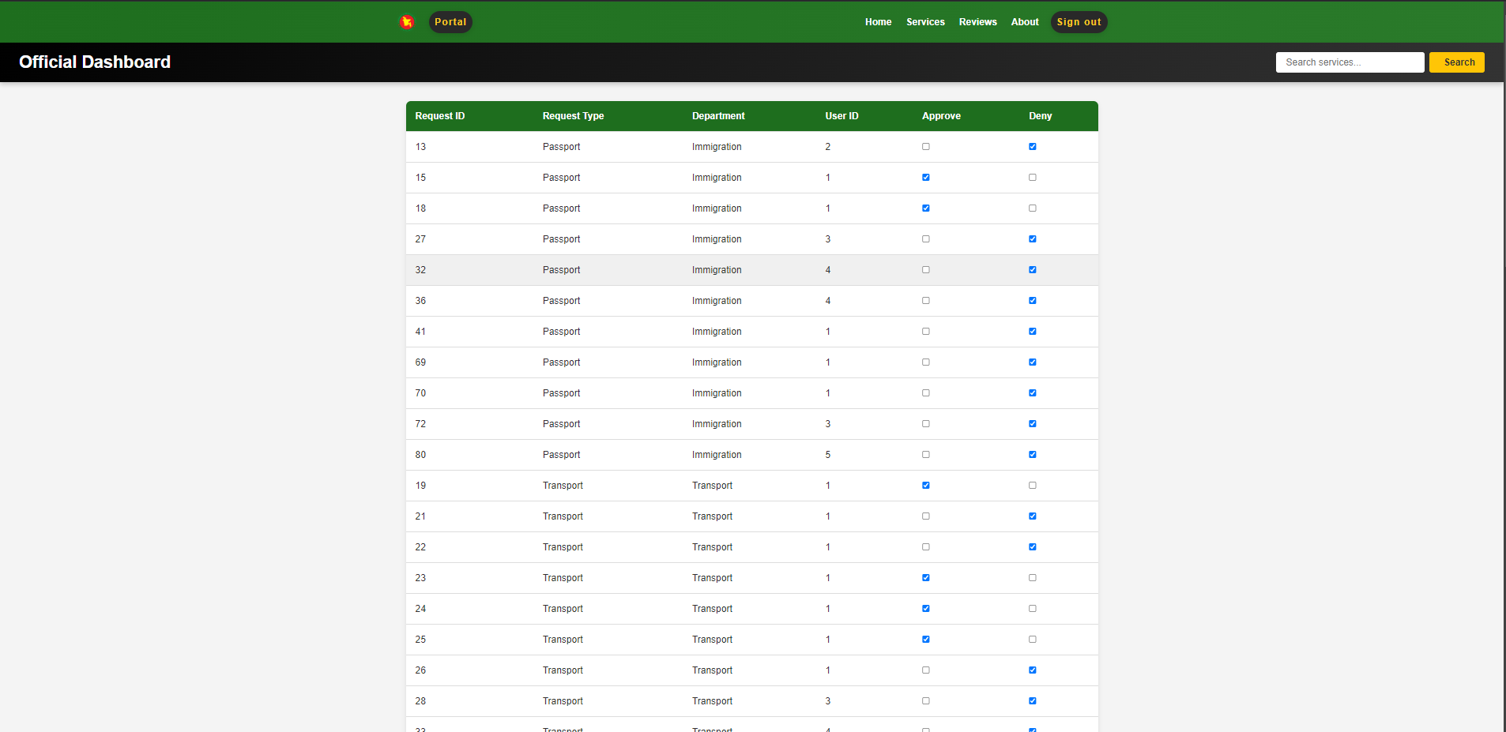

**Admin** 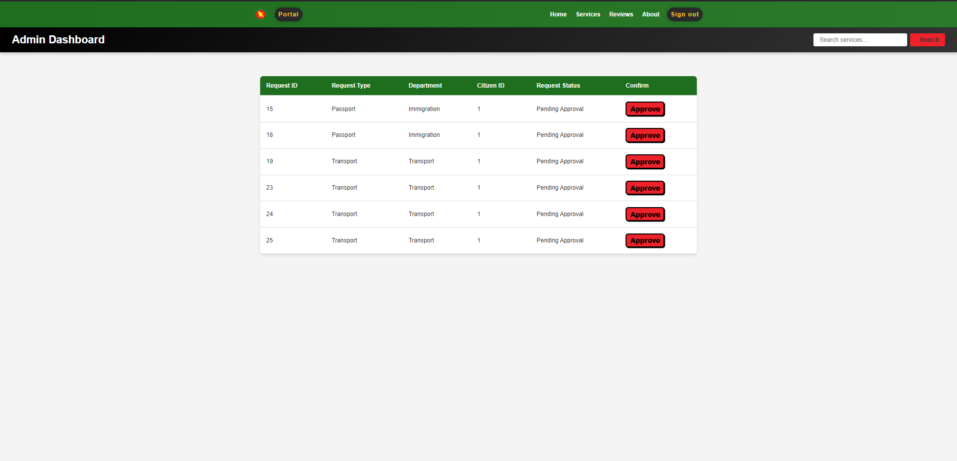

**Review** 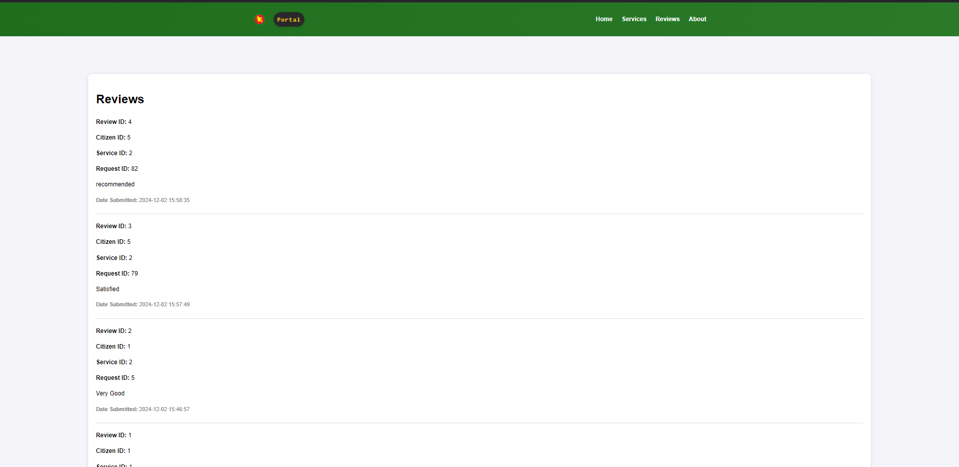

**User Sign Up  
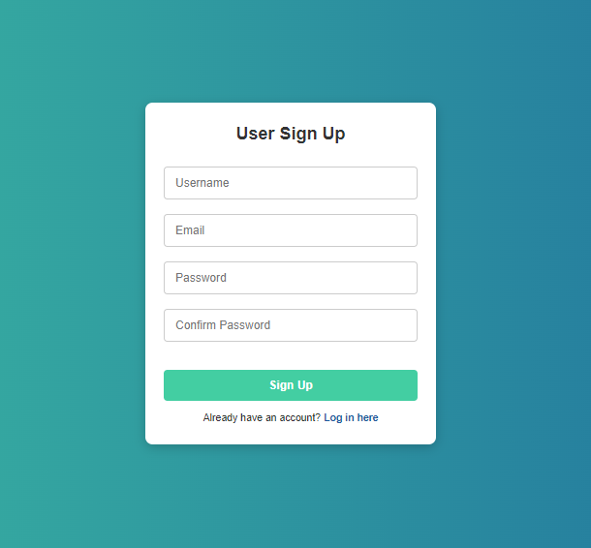**

**Conclusion:**